Donate in Construction of Masjid Nabvi Qureshi Hashmi Islamabad Pakistan

Legal Approvals Documents

"Masjid Nabvi Qureshi Hashmi is a registered mosque and has received all legal approvals from the government. To view and check our approvals and mission, click here to see all media files about masjid."

[Legal Approvals](https://drive.google.com/drive/folders/1M7TAbw7LTk4GMCWAfX_-B1AQTGDUn8rf?usp=drive_link)

[Media Files](https://drive.google.com/drive/folders/1ZjZWYSh5gNLRKcobKQU1E7WSvdlH3Dmw?usp=drive_link)

Masjid Nabvi Qureshi Hashmi's building is now Under Construction With All Legal Approvals so now you have chance to contribute in construction on masjid e Nabawi's model Masjid and Get your home in Jannah. so Donate now in Masjids Account and Contact with us. Additionally, we are working on creating a platform with live tracking, transparent accounts, and a voting system to empower people to change their situations as they desire by connecting with Masajids. We aim to provide a self-governance system, where society members, individual business owners, and administrators can collaborate effectively.

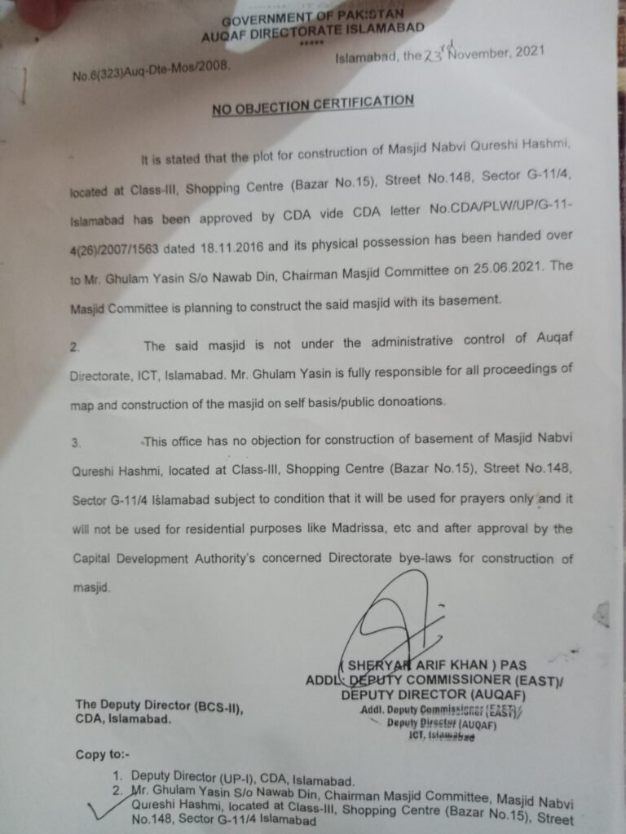

Great news! You have the opportunity to make a positive impact in your community! The DC Islamabad has authorized raising donations for the construction of a masjid. By contributing to this project, you are able to play an active role in building a place of worship for the community. Your generosity will not only benefit those who seek solace in the masjid, but also have a greater impact in promoting unity, compassion, and generosity in the community. Let’s work together to create a legacy that will be remembered for generations to come.

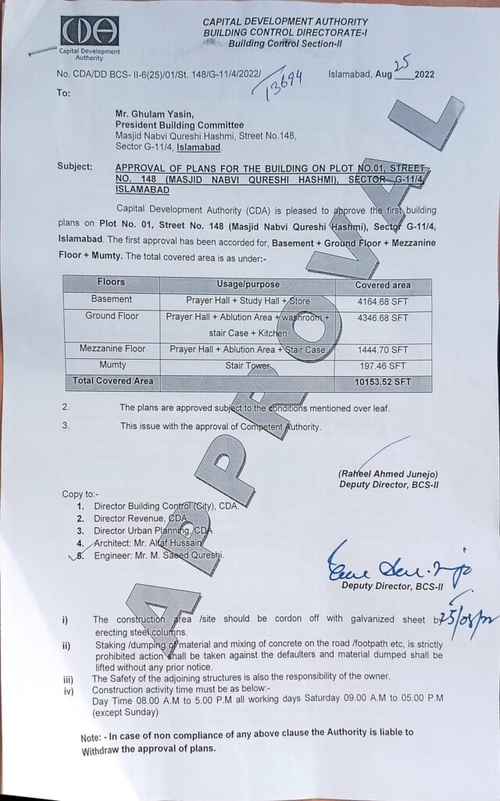

Building Plan Approval from CDA

“The construction plan for Masjid Nabvi has received approval from the government authority.”

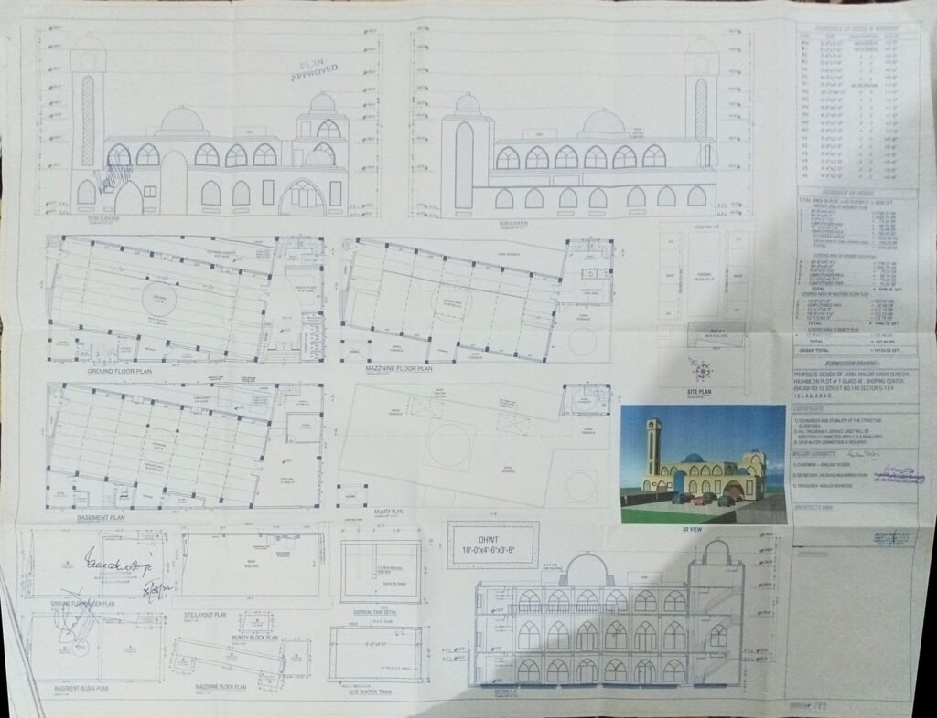

Final approved Building Plan

Building Plan Diagram

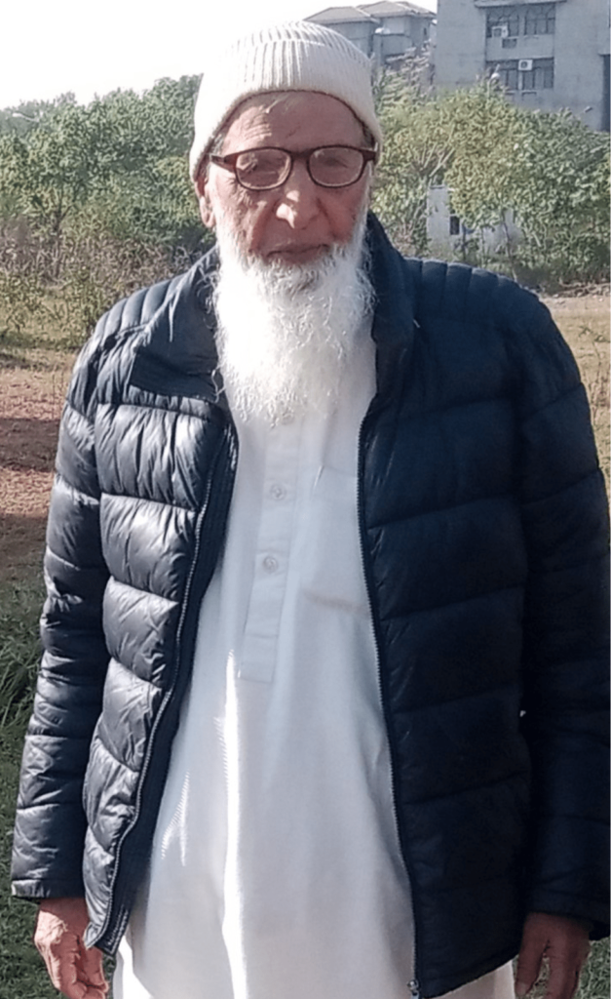

**Chairman Intzamia Commetty Masjid Nabvi Qureshi Hashmi Islamabad Pakistan**

***Haji Ghulam Yasin***

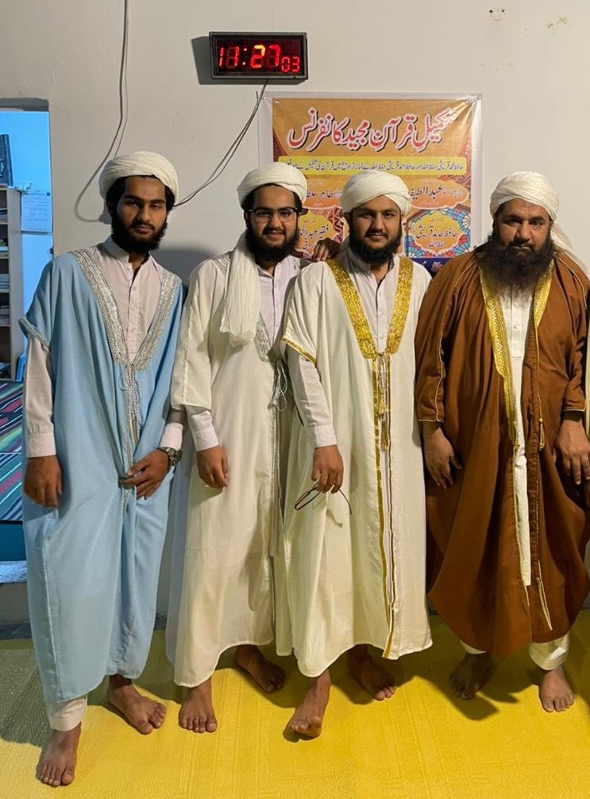

Founder, Voice Chairman and Imam of Masjid Nabvi Qureshi Hashmi Molana Abdul Ghaffar Qureshi with Naib Imams and Administration of Masjid Nabvi Qureshi hashmi

مسجد نبوی كے طرز پر سارے اعمال كا آغاز مسجد ھٰذا سے

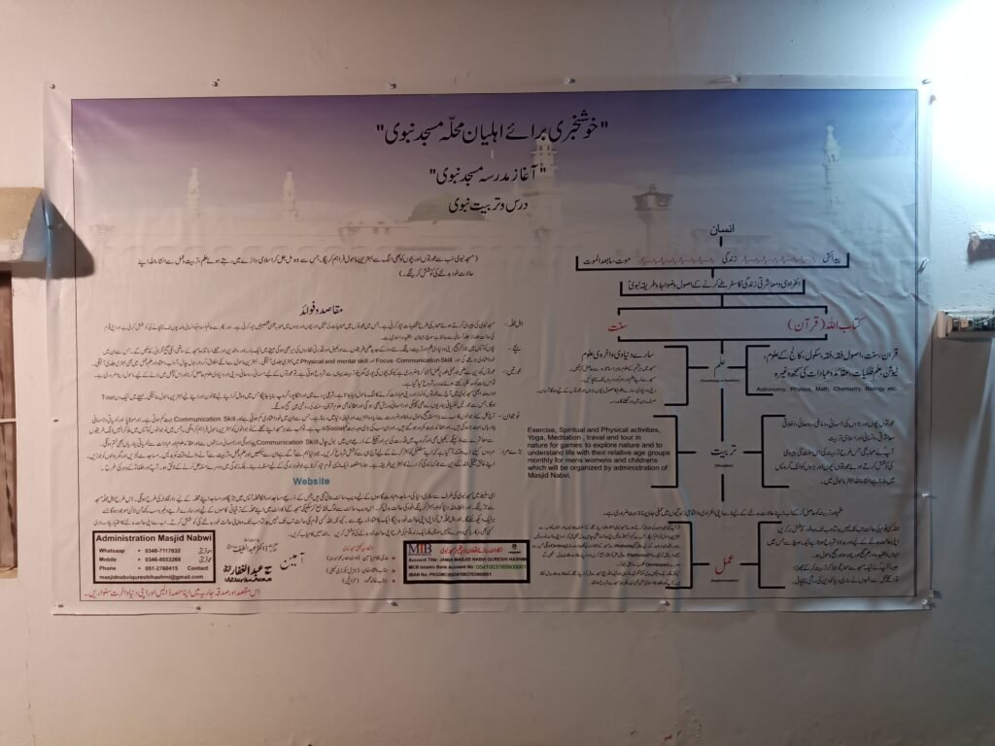

Masjid Nabvi Qureshi Hashmi’s mission

مسجد نبوی كے طرز پر سارے اعمال كا آغاز مسجد ھٰذا سے



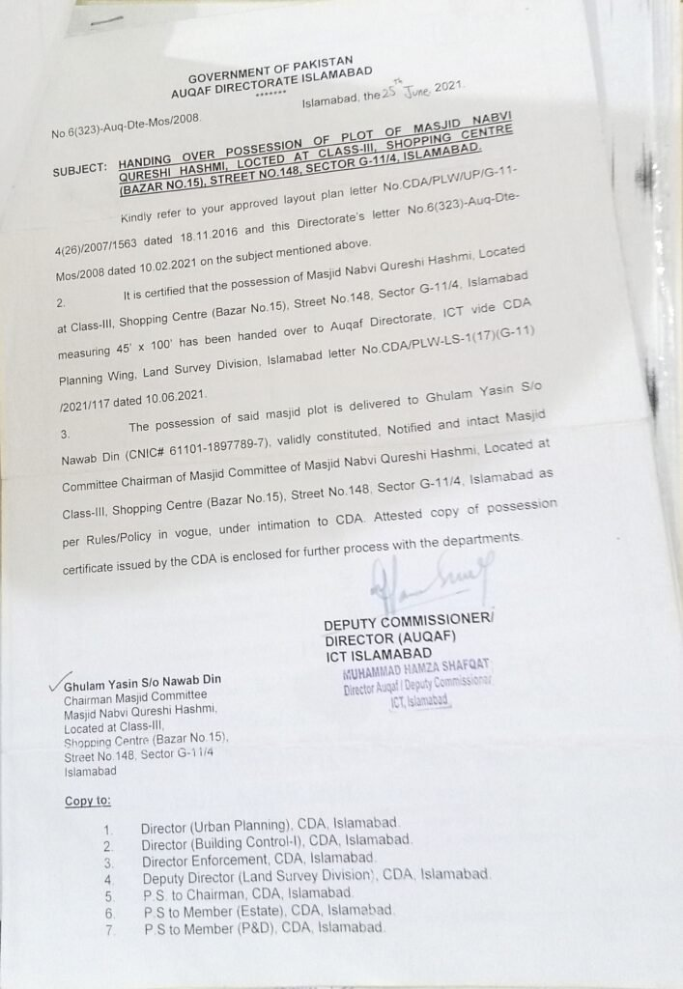

Possession Issued

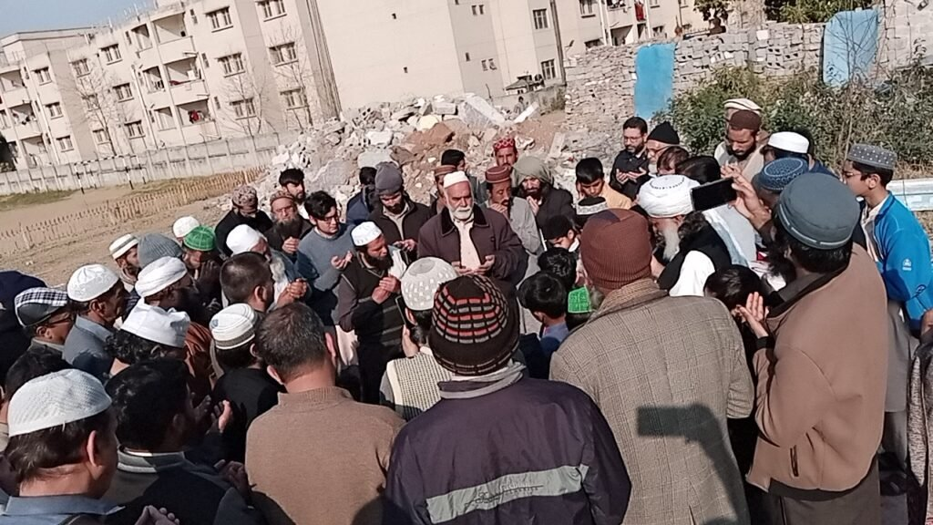

افتتاحی تقریب

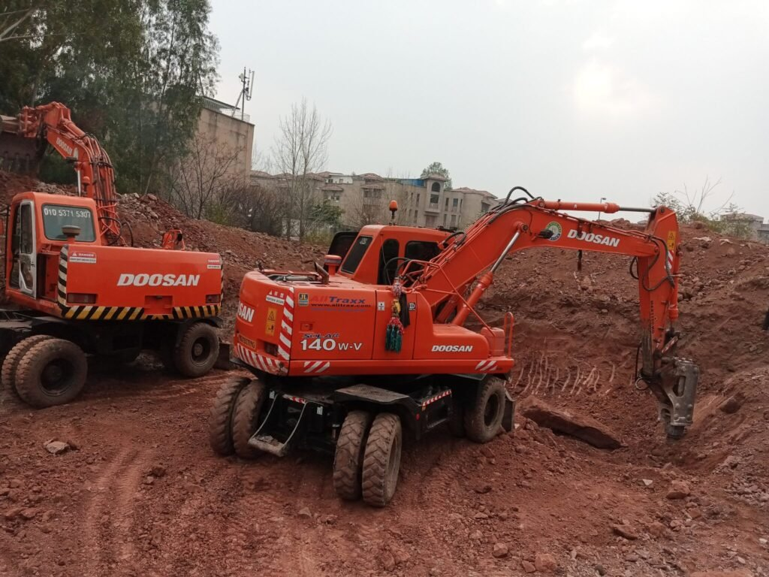

مسجد نبوی كی تعمیر شروع  
كھدای كے بیچ میں پتھر تورتے ہوے

stone in way of construction

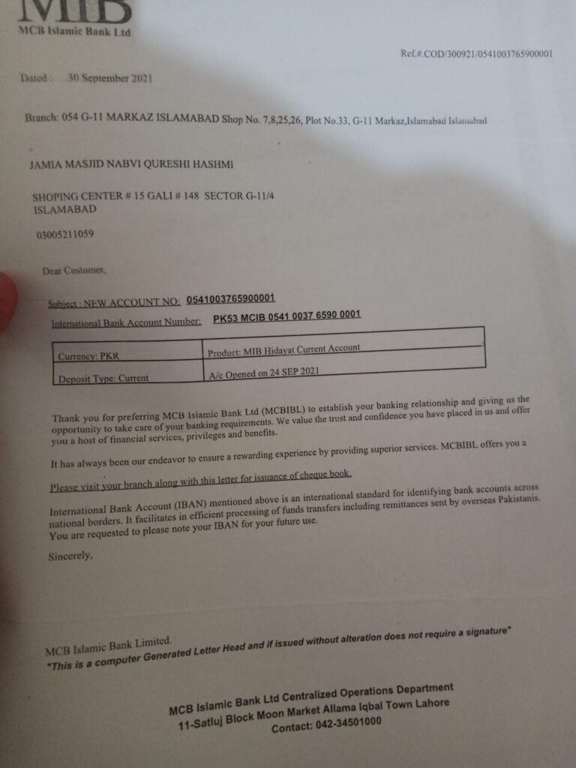

Masjid Bank Account

MCB authorized Bank account

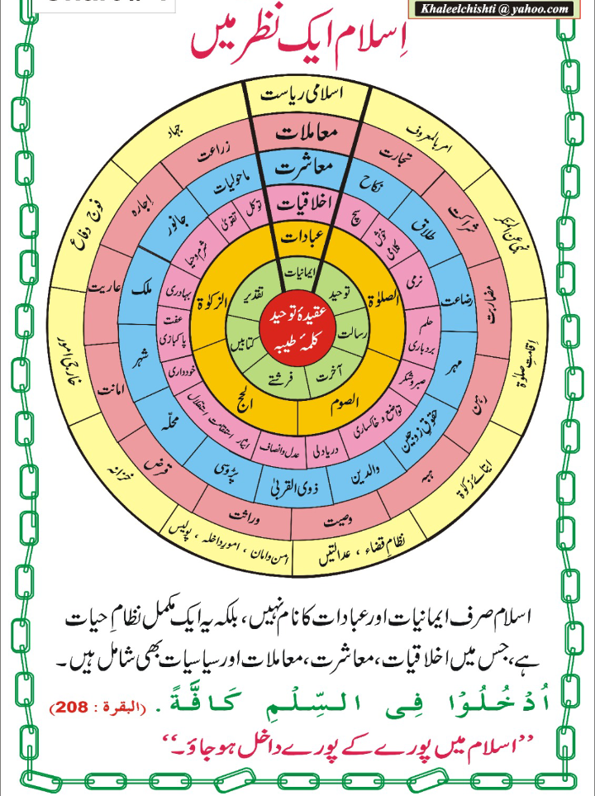

Chairman Haji Ghulam Yasin, along with the founder, Khateeb, and Imam of Masjid Nabvi Qureshi Hashmi, Molana Abdul Ghaffar Qureshi, are all inspired by the vision and mission of Masjid e Nabawi's model.

Two 25-year-old friends are on a mission to revolutionize the world’s educational, political, and all systems by connecting societies with their centers. They are creating a platform to connect societies with their centers and provide a self-governance system with live-tracking, transparent accounts, and a voting system. Their ultimate goal is to build a free nation inspired by the model of Masjid e Nabawi.

Founders Vision

Masajids should serve as capitals for their societies, just like countries have their own capitals. The purpose of Masjid Nabvi Qureshi Hashmi is to replicate the Riasat e Madina’s model created by Prophet Muhammad (S.A.W). This private masjid is run entirely by volunteers and is situated in G11/4 Islamabad, with all necessary building approvals from the CDA. Construction is ongoing, and the community has an opportunity to contribute to the cause. The founders, Molana Abdul Ghaffar Qureshi and his friend 25-year-old Haji Ghulam Yasin, ware financially stable Retired government officers who initiated the mission to establish Masjid Nabvi in Islamabad on Masjid e Nabawi’s Model. The younger generation, represented by Muhammad, Ahmed, and Hamid, is carrying the mission forward with aiming is to awaken Muslims and create a center for Islamic leadership, just as Prophet Muhammad (S.A.W) did in Madina by sharing knowledge and providing an environment for Muslims to grow. The founders’ vision is to bring Muslim societies back to Riasat e Madina’s model where communities worked together to make decisions. The current system created during the English colonial era has created a slave mentality, and Masajids were no longer used for the welfare of communities. To change this, Muhammad Qureshi is working to create a platform where People can connect with their with their relative canters like masjid for muslims in which we’ll give them live tracking transparent account and voting system so they’ll be able to make their society as they want with a trustable platform and individuals also be able to create profiles and earn with their skills like fiver etc. This platform would serve as a society management system with transparent payment and accountability and would allow everyone to participate in changing their society. The proposal seeks to connect communities with their local centers, Masjids, and Churches to collaborate on community projects using transparent and democratic voting systems.  A scientific game will also be developed to foster interest in science and technology. The long-term plan is to address the challenges the world is facing, such as climate change, inequality, and lack of Social gathering and access to education, and healthcare. with time to time we’ll work to built this system globally so then people will choose decisions from their society to city to country to world level decisions and also could control their reality

* The long-term plan is to address global issues such as climate change, inequality, and the lack of access to education and healthcare. Join us in this mission by professional team and funding.



Muslims and masajid's in Islam

**1.**The Multi-Faceted Role of Masajids in Islam\*\***

**Introduction:** Masajids, commonly known as mosques, are not just places of

worship but serve as dynamic hubs for the Muslim community. Their significance goes beyond daily prayers, extending into the realms of education, community engagement, and social welfare. This multifaceted role of Masajids plays a crucial part in the lives of Muslims, fostering unity, knowledge, and compassion.

**House of Worship:** At its core, Masajids are dedicated to worship, providing a sacred space for Muslims to establish a connection with Allah. They are the venues for the five daily prayers and the Jumu’ah (Friday) congregational prayer. These acts of worship are the cornerstone of a Muslim’s daily life, nurturing spiritual growth and devotion.

**Community Center:** Masajids act as vibrant community centers, serving as gathering places for Muslims. They host a wide range of social events, educational programs, and cultural activities. Through these initiatives, they create a sense of unity, solidarity, and belonging among community members.

**Education Hub:** Many Masajids serve as educational hubs, offering a diverse curriculum that includes Quranic studies, Islamic jurisprudence, and the life of Prophet Muhammad. By providing access to Islamic knowledge, Masajids empower individuals to live in accordance with Islamic principles and values, both in this world and the hereafter.

**Guidance and Counseling:** The spiritual leaders, including Imams and scholars, play a pivotal role in Masajids by offering guidance, counseling, and support to community members in times of spiritual or personal need. They serve as mentors and sources of inspiration, helping individuals navigate life’s challenges.

**Charitable Activities:** Masajids are actively involved in charitable activities, reflecting the compassionate teachings of Islam. They distribute food to the needy, provide financial assistance to those facing hardship, and support various social welfare initiatives. These acts of charity uphold the principles of compassion and generosity at the heart of Islam.

**Conclusion:** Masajids are not merely places of worship; they are dynamic institutions that enrich the lives of Muslims in numerous ways. By embracing their multifaceted role, we can uplift ourselves and our communities, promoting a culture of inclusivity, learning, and charity work. Through the spiritual guidance provided within these sacred walls, we grow personally and spiritually, finding unity, strength, and empowerment. Masajids are indeed the heart of our communities, and we should take pride in their vital role in our lives.

**2.**Transformation of Humanity: Before and After Islam\*\***

**Introduction:**  
The advent of Islam heralded a transformative era in human history, reshaping societies, values, and moral principles. Before Islam, various regions, including Arabia, were characterized by tribalism, idol worship, and social injustices. In contrast, the message of Islam, brought by Prophet Muhammad, ushered in a new era of monotheism, justice, education, and a sense of purpose. This transformation significantly improved the condition of humanity and left a lasting impact.

**Before Islam:**

1. **Tribalism and Warfare:** Pre-Islamic Arabian society was deeply divided along tribal lines, leading to frequent conflicts and warfare. Tribal loyalties often took precedence over moral values.

2. **Idol Worship:** The prevalent practice of idol worship hindered the spiritual development of the population. The Kaaba in Mecca, originally built for monotheistic worship, had become a center for idolatry.

3. **Injustice and Inequality:** In several parts of the world, including Persia and Rome, kings held absolute power, while the rights of common people, especially slaves, were virtually non-existent. Injustice and inequality were widespread.

4. **Lack of Scientific Progress:** Scientific knowledge and inquiry were limited before Islam. The pursuit of science and learning was not a priority in many societies.

**After Islam:**

1. **Monotheism and Unity:** Islam brought the concept of monotheism, emphasizing the belief in one God. Muslims formed a united community (Ummah) that transcended tribal divisions.

2. **Justice and Moral Values:** Islam introduced principles of equality, justice, and moral values. It emphasized the fair treatment of all individuals, regardless of their social status.

3. **Empowerment of Women:** Islam significantly improved the status of women in society. It granted them rights and protections, challenging the pre-existing norms of gender inequality.

4. **Education and Knowledge:** Islam encouraged the pursuit of education and knowledge. Islamic scholars made significant contributions to various fields, including science, mathematics, medicine, and philosophy. The Islamic Golden Age witnessed remarkable advancements in these areas.

5. **Guidance and Purpose:** The Quran provided comprehensive guidance for all aspects of life, instilling a sense of purpose and spirituality among its followers. It emphasized ethical conduct and personal development.

**Conclusion:**  
  
The transformation brought about by Islam is profound and enduring. It shifted humanity from a state of tribalism, idol worship, and injustice to a realm of monotheism, justice, education, and moral values. The empowerment of individuals, the promotion of knowledge, and the emphasis on equality have been pivotal in shaping the world as we know it today. The message of Islam continues to inspire individuals to strive for a better world and a more just and inclusive society.

The adoption of Islam has transformed humanity for the better. Our values and morals have shifted towards monotheism, justice, education, and a sense of purpose. Our commitment to fighting against harmful practices and promoting a culture of inclusivity and fairness is more important now than ever before. By embracing these values and striving to live our lives according to the principles of Islam, we can make the world a better place.

Before the advent of Islam, Arabian society was marked by tribalism, warfare, and idol worship. With the arrival of Islam and the message brought by Prophet Muhammad, a transformation occurred. Muslims embraced monotheism (belief in one God), adopted a code of ethics, and gained a sense of unity as a community (Ummah).

Islam brought significant changes to the lives of individuals. It emphasized equality, justice, and moral values. It improved the status of women, abolished harmful practices, and promoted education and knowledge. The Quran provided guidance for all aspects of life, fostering a sense of purpose and spirituality.

**3.**Prophet Muhammad’s Vision: Building a Nation from Masjid e Nabawi, Madina\*\***

**Introduction:** The migration of Prophet Muhammad (peace be upon him) to Madina in 622 CE marked a pivotal moment in history, not only for Islam but for the entire world. In Madina, the Prophet’s leadership and vision laid the foundation for a strong sense of community and brotherhood, establishing a model that continues to inspire societies around the globe. This article explores how Prophet Muhammad created a nation from Masjid e Nabawi in Madina, emphasizing unity, justice, and collective decision-making.

**The Constitution of Madina:** One of the Prophet’s first acts in Madina was the signing of the Constitution of Madina. This historic document outlined the rights and responsibilities of all citizens, irrespective of their religion or tribal affiliations. It established a framework for a pluralistic society, where diverse communities coexisted harmoniously under Islamic governance. This revolutionary concept of inclusivity set the stage for building a united nation.

**Masjid e Nabawi:**

**The Spiritual and Administrative Center:** Prophet Muhammad designated Masjid e Nabawi as the spiritual and administrative heart of the nascent Islamic state. It served as more than just a place of worship; it became a hub for decision-making, discussions, and community gatherings. Within its walls, the Prophet promoted collective decision-making and consultation, ensuring that every voice was heard. Masjid e Nabawi transcended its role as a mere mosque; it became the epicenter of a burgeoning nation.

**Unity and Brotherhood:** In Madina, Prophet Muhammad fostered a profound sense of unity and brotherhood among its inhabitants. This unity transcended the boundaries of tribalism, as the Muhajirun (migrants) and Ansar (helpers) came together as one community. The Prophet’s teachings emphasized the bonds of faith and fraternity, highlighting the importance of treating one another with kindness and compassion. This sense of unity laid the foundation for a cohesive Muslim nation.

**Justice and Dispute Resolution:** To maintain peace and justice in the community, Prophet Muhammad established a system of justice and arbitration. Disputes were resolved through fair and impartial means, ensuring that everyone received their due rights. This commitment to justice was a cornerstone of the Islamic state, setting a precedent for the rule of law.

**Conclusion:** Prophet Muhammad’s leadership and vision in Madina serve as a timeless example of nation-building through unity, justice, and collective decision-making. His actions at Masjid e Nabawi, the signing of the Constitution of Madina, and the promotion of brotherhood among diverse communities laid the foundation for a strong and cohesive Muslim nation. Today, these principles continue to inspire societies worldwide, offering a path towards a better, more just, and inclusive world for all.

**4.**The Legacy of Islamic Civilization: Advancing Science, Education, and Democracy**

**Introduction:** The Golden Age of Islamic civilization, spanning from the 8th to the 13th centuries, serves as a testament to the remarkable contributions made by Muslims in the realms of science, education, and the principles that underlie democracy. This article highlights how Muslim scholars and thinkers ruled and changed the world by championing knowledge, inquiry, and governance based on consultation and justice.

**Advancements in Science and Medicine:** During the Islamic Golden Age, luminaries such as Ibn Sina (Avicenna), Al-Razi (Rhazes), and Al-Biruni made profound strides in various scientific disciplines. Their pioneering contributions to fields like medicine, mathematics, astronomy, and optics laid the foundation for modern scientific thought. The House of Wisdom in Baghdad played a pivotal role by translating and preserving Greek and Roman texts, thereby expanding the horizons of human knowledge.

**The Pursuit of Knowledge and Educational Excellence:** Islamic civilization can be credited with establishing some of the world’s first universities and libraries. These institutions became centers of learning, where scholars from diverse backgrounds convened to exchange ideas and explore the depths of knowledge. The preservation and expansion of classical texts enriched human understanding and set a precedent for the pursuit of excellence in education.

**Roots of Consultation and Justice in Islamic Tradition:** While contemporary democracy may differ in structure from historical Islamic governance, the principles of consultation (Shura) and justice are deeply rooted in Islamic tradition. The concept of Shura encourages collective decision-making, whereby leaders seek counsel and input from the community. This principle of consultation aligns with democratic ideals of participatory governance.

**Laying the Foundations for Democratic Ideas:** Muslim scholars not only practiced Shura but also articulated principles of justice and equitable governance. These foundational ideas paved the way for later developments in democratic thought. The principles of accountability, rule of law, and justice were integral components of Islamic governance.

**Conclusion:** The legacy of Islamic civilization, characterized by advancements in science, a commitment to education, and the principles of consultation and justice, continues to inspire and shape the modern world. By embracing the values of learning, inquiry, and participatory governance, Muslims can continue to make a positive impact on the global stage and contribute to the betterment of humanity.

**5.**British Colonialism in Asia: Education, Control, and the Path to Independence**

**Introduction:** The era of British colonialism in Asia left an indelible mark on the region, shaping its history, society, and governance. While this period brought about many challenges, it also ignited a fervent desire for independence and self-determination among Asian communities. This article explores the British colonial legacy, with a particular focus on the educational and control systems they implemented, and highlights the resilience and resourcefulness of these communities in their pursuit of a brighter future.

**British Strategies for Control:**

1. *Divide and Rule:* The British Empire employed a divisive strategy that sought to pit communities against each other based on religious, ethnic, and caste lines. This fragmentation was a deliberate attempt to thwart any unified resistance to British rule.

2. *Educational Reforms:* One of the significant tools of control was the introduction of a Western-style education system. This system aimed to create a class of educated elites who would remain loyal to British rule. The traditional educational system, often centered around masajids (mosques), was replaced with a curriculum designed to serve British interests.

3. *Economic Exploitation:* British colonialism in Asia was marked by the extraction of valuable resources from the region, which were exploited for the benefit of the British Empire. This economic exploitation had a profound impact on the economies of Asian countries.

4. *Administrative Structures:* The British established complex colonial bureaucracies to govern the territories they controlled. These structures often prioritized British interests over the welfare of local populations, perpetuating a system of control.

**The Legacy of Colonialism:** The legacy of British colonialism in Asia is complex. While it left behind significant challenges, including the enduring effects of the educational and control systems imposed, it also ignited the flames of independence. The desire for self-determination, social justice, and freedom became powerful motivators for Asian communities.

**Moving Forward with Masjid e Nabawi’s Model:** It is now imperative for Asian nations to reflect on their colonial history and the enduring effects of British rule. Embracing a model that promotes freedom, unity, and inclusivity, such as the one exemplified by Masjid e Nabawi, offers a path forward. This model, designed for the creation of a free nation, can help overcome the legacy of colonialism and the mindset of subjugation that lingers.

**Conclusion:** British colonialism in Asia brought about significant challenges, including changes to education and control systems that continue to impact the region. However, the resilience and resourcefulness of Asian communities, coupled with a commitment to education and a shared vision for the future, have the potential to pave the way for a brighter and more independent future.

**6.**The Birth of Pakistan: Struggle for Independence and the Quest for an Islamic Nation**

**Introduction:** The creation of Pakistan in 1947 marked a historic moment in the struggle for independence in South Asia. This article delves into the reasons behind Pakistan’s formation and the subsequent challenges it faced, particularly the need to embrace an Islamic system inspired by the model of Masjid e Nabawi for a prosperous and united nation.

**The Desire for Self-Determination:** The desire for self-determination and autonomy was a driving force behind the struggle for independence. Muslims in South Asia sought the freedom to govern their own affairs and establish a nation where they could practice their religion without hindrance.

**Impact of British Colonial Rule:** British colonial rule had a profound impact on the Indian subcontinent. It brought about changes in governance, education, and societal norms. The educational system introduced by the British played a role in shaping the mindset of the population, and the administrative structures they imposed left a lasting legacy.

**Leadership of Muhammad Ali Jinnah:** The leadership of Muhammad Ali Jinnah was pivotal in the quest for Pakistan. Jinnah’s vision, determination, and tireless efforts were instrumental in the creation of a separate nation for Muslims. His advocacy for religious and political autonomy resonated with the Muslim-majority regions.

**Pakistan’s Formation and Initial Challenges:** In 1947, as India gained independence from British rule, Pakistan was born as a separate nation for Muslims. However, the initial years were fraught with challenges, including the need to establish a governance system that aligned with the principles of Islam.

**The Quest for an Islamic Nation:** Pakistan was founded on the principles of Islam, with the Quran as its constitution and the teachings of Prophet Muhammad as a guiding light. However, over time, the influence of colonial-era systems and a failure to fully embrace the ideals of an Islamic state led to challenges.

**Embracing the Model of Masjid e Nabawi:** To overcome the challenges and realize the vision of a prosperous and united Pakistan, it is crucial to embrace the model of Masjid e Nabawi. This model, designed to create a free nation based on Islamic principles, offers a path forward. By aligning Pakistan’s systems and governance with the teachings of Islam, the nation can achieve its true potential.

**Conclusion:** The birth of Pakistan was driven by the desire for religious and political autonomy. As Pakistan faces contemporary challenges, it is essential to revisit its founding principles and embrace the ideals of an Islamic state inspired by the model of Masjid e Nabawi. This path can lead Pakistan towards greater prosperity and unity, fulfilling the dreams of its founders.

**7.**Pakistan’s Current Challenges and the Youth Migration Issue**

**Introduction:** Pakistan is a nation blessed with abundant natural resources, diverse landscapes, and a rich cultural heritage. However, despite these blessings, the country faces various challenges, including political instability, economic issues, and security concerns. One pressing issue is the migration of its youth in search of better opportunities abroad. This article explores the reasons behind youth migration, the need for reform, and the potential solution through the implementation of Masjid Nabawi’s model.

**The Blessings and Challenges:** Pakistan’s geographical diversity, from mountains to plains, and its four distinct seasons make it a land of natural beauty. However, these blessings have been accompanied by challenges such as political instability, economic disparities, and security issues.

**Youth Migration:** Despite the nation’s potential, many young Pakistanis are leaving the country in search of better opportunities elsewhere. The reasons behind this migration include limited employment prospects, the desire for improved living standards, and a perceived lack of opportunities within Pakistan.

**Brain Drain and its Consequences:** The migration of talented and educated youth has led to a brain drain, where Pakistan loses its skilled workforce to other countries. While these individuals contribute to their adopted nations, Pakistan loses the expertise and potential that could have fueled its own development.

**The Need for Reform:** The migration issue underscores the urgent need for reform in Pakistan. Reforms should encompass various sectors, including education, employment, governance, and justice. By addressing these areas, Pakistan can create an environment that retains and attracts its youth.

**Implementing Masjid Nabawi’s Model:** One way to reform Pakistan’s systems and governance is by implementing the model of Masjid Nabawi. This model, rooted in Islamic principles, promotes democracy, transparency, and community engagement. By connecting masajids across the nation, Pakistan can make decisions collectively and ensure that the voice of the people is heard.

**Conclusion:** Pakistan’s current challenges, including youth migration, require comprehensive reform in various sectors. The nation must tap into its potential and create opportunities for its youth to thrive. Implementing Masjid Nabawi’s model can be a step towards a brighter future, where Pakistan’s youth can contribute to their homeland’s prosperity and development. It is time for Pakistan to harness its blessings and overcome its challenges by embracing positive change.

**8.**Transforming Pakistan and the World with the Model of Masjid e Nabawi**

**Introduction:** The principles and values embodied by Masjid e Nabawi provide a profound model that can have a transformative impact on societies worldwide. By embracing self-governance, transparency, and inclusivity, we have the potential to build fairer and more empowering communities, both in Pakistan and beyond.

**The Model of Masjid e Nabawi:** The Masjid e Nabawi model places a strong emphasis on community engagement, education, and unity. When applied to all masajids, this model has the potential to create a platform for self-governance and transparency, two vital components of a thriving society. By empowering communities to collectively make decisions, we can establish true democracy, where every individual has a voice in shaping their future.

**Positive Change in Pakistan:** Implementing the model of Masjid e Nabawi in Pakistan can lead to significant positive changes. Through community empowerment and transparent decision-making processes, we can tackle pressing issues, drive social progress, and create a fairer and more just society. This transformation would not only benefit Pakistan but also inspire others worldwide.

**A Global Example:** Pakistan’s adoption of the Masjid e Nabawi model can serve as a shining example for the rest of the world. The principles of self-governance, inclusivity, and transparency resonate universally. By demonstrating the power of these values in action, Pakistan can inspire other nations to follow suit, fostering a global movement towards more just and equitable societies.

**Conclusion:** The model of Masjid e Nabawi is a beacon of hope and inspiration. By implementing this model in Pakistan and championing its values on the global stage, we have the opportunity to create a world where self-governance, transparency, and inclusivity prevail. Together, we can be the architects of a brighter and fairer future, one that reflects the principles laid out in the legacy of Prophet Muhammad and the sacred Masjid e Nabawi.

 **9.**Our Roadmap**

**for Transformation: Building a Platform for Self-Governance and Transparency**

**Introduction:** Our roadmap is guided by the principles of self-governance, transparency, and inclusivity. We are committed to creating a platform that empowers communities and individuals to make informed decisions and fosters a strong sense of community. This platform will serve as a catalyst for positive change in Pakistan and beyond.

**The Vision:** Our vision involves building a comprehensive platform that incorporates live tracking, transparent accounts, and a robust voting system. This platform will connect people with their society centers, similar to masjids for Muslims, and enable them to participate actively in decision-making processes.

**Empowering Self-Governance:** Central to our roadmap is the idea of self-governance. We believe that communities should have the autonomy to make decisions that directly impact their lives. Our platform will facilitate this by providing the tools and mechanisms needed for self-governance.

**Transparency in Decision-Making:** Transparency is another core principle driving our roadmap. We aim to ensure that every decision made within a community is visible and accountable. Transparent accounts will be a hallmark of our platform, instilling trust and confidence among users.

**Inclusivity for All:** Our platform is not limited to any specific group; it is designed to be inclusive and accessible to everyone. Just as masjids serve as community centers for Muslims, our platform will be open to all, fostering unity and cooperation among diverse groups.

**Seeking Professional Teams and Funding:** To bring our vision to life, we are actively seeking professional teams and funding. Building a platform of this magnitude requires expertise, dedication, and resources. We invite individuals and organizations who share our passion for positive change to join us on this journey.

**Conclusion:** Our roadmap is a testament to our commitment to creating a world that is fairer, more empowering, and driven by the principles of self-governance and transparency. Together, we can build a platform that empowers communities, strengthens democracy, and serves as a model for positive change. Join us in our effort to make a meaningful difference in Pakistan and beyond.

**10.** Join Us in Building a Brighter Future\*\***

**Introduction:**  
The power to change the world lies within each of us, and together, we can transform our vision into reality. We are on a mission to bring positive change to our communities and the world at large. To achieve this, we need the support of dedicated professionals and funding partners who share our vision.

**Our Vision:**  
Our vision is to create a platform that promotes self-governance, transparency, and inclusivity. We aim to empower communities and individuals to actively participate in decision-making processes, fostering a stronger sense of community and democracy.

**Your Invitation:**  
We invite you to join us in this transformative journey. Whether you are a professional with the expertise to contribute, a visionary with a passion for change, or an organization looking to make a meaningful impact, your involvement can make a difference.

**How You Can Contribute:**  
1. **Professional Expertise:** If you have skills and experience in technology, project management, community engagement, or related fields, your expertise is invaluable. Join our team and help bring our platform to life.

2. **Financial Support:** Funding is crucial to realizing our vision. Your financial contribution, whether large or small, will directly contribute to building a platform that can change lives.

3. **Spread the Word:** Even if you can’t directly contribute, you

can still help by spreading the word. Share our mission with your network, friends, and colleagues. Your advocacy can attract like-minded individuals and organizations to our cause.

**Conclusion:**  
The journey towards a brighter future begins with each step we take together. Join us in our mission to empower communities, promote transparency, and foster self-governance. Together, we can make a positive impact on our communities and the world. Come and be a part of the change today!

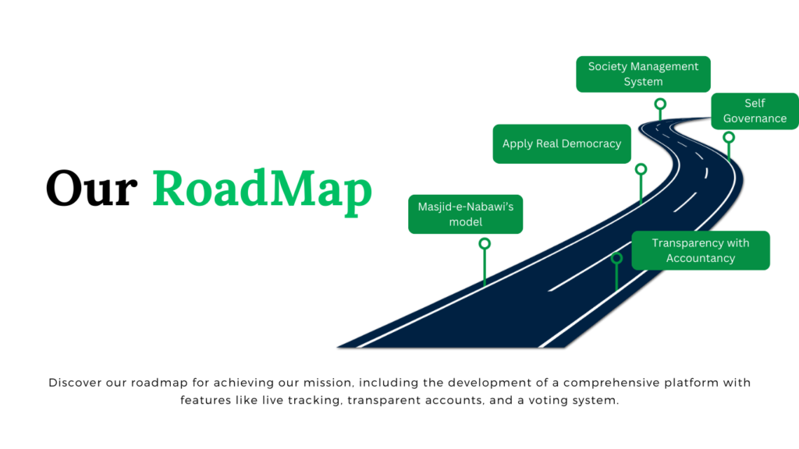

**Embracing the Vision of Masjid Nabawi: Strengthening Communities**

**Introduction:** In the spirit of Prophet Muhammad’s (peace and blessings be upon him) establishment of Masjid Nabawi as a central institution in Medina, we are inspired to reimagine the role of mosques in our communities. Just as the Prophet aimed to build a united Muslim nation from the mosque, we recognize the vital role mosques play as civic centers for Muslims today. This transformative vision seeks to utilize mosques as catalysts for change by focusing on knowledge, training, and collective action.

**The Role of Mosques: Beyond Worship:** Mosques are not merely places of worship but serve as vibrant centers for our communities. They provide the ideal platform for Muslims to come together, connect, and collectively strive for positive change. Recognizing the importance of prayer in the Quran, mosques facilitate congregational prayers, fostering unity and collaboration among individuals.

**Mosques as Educational Hubs:** Just as Prophet Muhammad provided guidance and enlightenment to his companions in Masjid Nabawi, many mosques today serve as educational hubs. They offer diverse programs covering Quranic studies, Islamic jurisprudence, and the life of the Prophet. These initiatives are crucial for nurturing an informed and enlightened Muslim community.

**Personal Growth and Support:** Mosques are a source of spiritual growth and support, mirroring the guidance and counseling the Prophet offered in Masjid Nabawi. Modern imams, scholars, and religious leaders continue this tradition by providing mentorship and assistance to community members in their times of need.

**Advancement in Science and Knowledge:** In line with the spirit of Masjid Nabawi, mosques can become centers for the advancement of knowledge and science. They can foster discussions on contemporary issues, promote critical thinking, and encourage scientific pursuits while staying within the bounds of Islamic principles.

**Charity and Social Welfare:** Just as the Prophet emphasized charity and helping the less fortunate, many mosques are engaged in charitable activities. They distribute food, provide financial assistance, and support various social welfare initiatives, embodying the values of compassion and generosity.

**Reviving the Spirit of Masjid Nabawi:** Our beloved country, Pakistan, was founded in the name of Islam, yet it faces challenges due to systems rooted in colonial-era control. To change our collective situation, we must embrace the model of Masjid Nabawi and work towards building a united nation that can positively impact the world.

**A Call to Action:** It is imperative that we transition to a system designed for a united nation, much like the one initiated by the Prophet in Masjid Nabawi. This transformation begins by connecting neighborhoods to their local mosques, where pressing issues can be addressed collectively. The mosque administration must involve the community in decision-making processes, ensuring transparency, and democratic principles.

**Creating a Global Network:** Our vision extends beyond local communities. We aspire to establish a society management system that empowers neighborhoods worldwide to connect with their centers, their mosques, and initiate positive change. Insha Allah, through collective effort and the blessing of Allah, we can achieve this vision.

**Conclusion:** As we embark on this transformative journey, let us remember the timeless wisdom of the Prophet Muhammad (peace and blessings be upon him) and the monumental role of Masjid Nabawi in building a united nation. Let us work together to create a brighter future for our communities, inspired by the spirit of Masjid Nabawi. May Allah guide and assist us in this noble endeavor. Ameen.

Muhammad Qureshi from Masjid Nabvi Qureshi Hashmi, Islamabad, Pakistan.

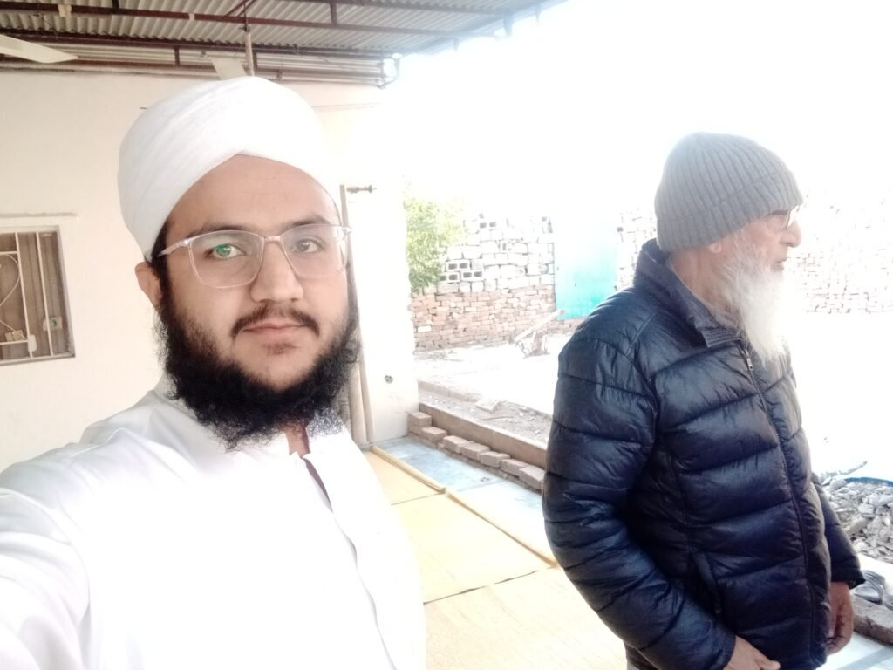

[Mission Explaning](https://drive.google.com/drive/folders/1Gv2wvZKJ_1WAHEmGB3Li7peDx_z13brW?usp=drive_link)

I am Muhammad Qureshi from Jamia Masjid Nabvi Qureshi Hashmi in Islamabad, Pakistan. Our masjid is fully volunteer-run, based on the model of Masjid e Nabawi, which played a pivotal role in the creation of a nation by Prophet Muhammad. We believe that in the current situation in Pakistan, masjids can be instrumental in bringing about positive change. Our masjid is currently under construction, and we are seeking donations for its completion. Additionally, we are working on creating a platform with live tracking, transparent accounts, and a voting system to empower people to change their situations as they desire. The mission is driven by the realization that the modern world, with abundant knowledge and ideas, often lacks collective action. We aim to provide a self-governance system, where society members, individual business owners, and administrators can collaborate effectively. Masjids have a significant role in Islam, serving as places of worship, education, and community gathering. The model of Masjid e Nabawi demonstrates how a strong community can be built around a masjid. Pakistan's journey to independence and its current problems, including educational issues and youth challenges, are factors motivating our mission. We aim to provide education, create a conducive environment for growth, and connect masjids with societies at all levels. Our roadmap includes the development of a comprehensive platform, user login, society administration, and various levels of administration, including city, country, and super admin roles. We invite everyone to join us in our mission to use masjids as catalysts for positive change in Pakistan and beyond. Proposal: The goal is to create a platform connecting communities with their local centers (like mosques), fostering collaboration on community projects and implementing transparent democratic voting systems. Additionally, they plan to develop a scientific game promoting interest in science and technology. This platform aims to address global challenges such as climate change, inequality, and limited access to education and healthcare. The ultimate vision is to transform the governmental system by connecting Masajids and their societies through live tracking, transparent accounting, and a voting system based on the model of Riasat e Madinah and Masjid e Nabawi. The Path Forward: By connecting societies, cities, countries, and the world through a transparent, democratic system, the mission aims to empower individuals to take charge of their societies and financial decisions. This mission seeks to implement a real democracy where every individual contributes to shaping their society and knows where their money is spent. In conclusion, this initiative envisions a brighter future where communities come together through their Masajids or their religious canters or community canters to address global challenges and foster collective progress, in line with the principles of Riasat e Madinah." For more details, please visit our Facebook page: [Jamia Masjid Nabvi Qureshi Hashmi G11/4 Islamabad](<https://www.facebook.com/nabviS.W.AMasjid/>).



**Founder, Khateeb, and Imam – Molana Abdul Ghaffar Qureshi’s Vision and Mission**

**How will we Use Masajid’s To create impact in the world**

**Vision: Masajids as Capitals for Societies**

 The vision of Masjid Nabvi Qureshi Hashmi is to transform mosques into centers of excellence, much like capitals are to countries. Our mission is inspired by the legacy of Prophet Muhammad (S.A.W) in Medina, where he united a nation. Masjid Nabvi Qureshi Hashmi is a private mosque located in G11/4, Islamabad, with full approval from CDA and Auqaf. The construction plan (naqsha) of Masjid Nabvi is also officially approved, and construction is currently underway. We invite you to contribute to this noble mission

 *Volunteer-Driven*

 Masjid Nabvi operates entirely on a volunteer basis. It was founded by Molana Abdul Ghaffar Qureshi and his long-time friend Haji Ghulam Yasin, both retired government officers with financial stability. Their mission is to establish Masjid Nabvi in Islamabad, aiming to awaken the spirit of unity and excellence among the Muslim community, mirroring the actions of Prophet Muhammad (S.A.W) in Medina.

*Continuation of the Legacy*

 Molana Abdul Ghaffar Qureshi and Haji Ghulam Yasin, now retired and over 60 and 80 years old, respectively, have entrusted their mission to Muhammad, Ahmed, and Hamid bin Abdul Ghaffar Qureshi. These young leaders are well-educated and understand the founders’ mission. Since 2015, they have been actively involved in leading prayers and Taraweeh in Masjid Nabvi voluntary

  *Creating a Trustable Platform*

 Muhammad Qureshi is initiating a Platform dedicated to religious centers worldwide, exclusive for Masajids. This platform will enable Muslims to create individual skill profiles for earning and will allow Masajids to connect with their society members. It’ll foster transparent financial transactions, ensuring donors can track how their contributions are utilized. To create this king of platform we need professional team support and funding because its not one man work.

  *The Oath to Continue the Mission*

Muhammad Qureshi pledges to continue this mission with unwavering dedication. In today’s world, filled with information and knowledge, many know how to improve but lack the necessary action. by creating this platform we aim to unite individuals, providing a trustworthy environment for collective efforts toward positive change.

 **Proposed Platform**

 Our proposal involves creating a platform that connects communities with their local centers, such as mosques and churches, fostering collaboration on community projects. It also features a transparent and democratic voting system. Additionally, we plan to develop a scientific game to stimulate interest in science and technology, addressing global challenges like climate change, inequality, and access to education and healthcare.

 **Future Vision**

Our future vision is to revolutionize the governmental system by connecting Masajids and their societies through live tracking, transparent accounts, and a voting system based on the concept of Riasat-e-Madinah and the model of Masjid-e-Nabawi. This will empower every society to make decisions as they desire, promoting collective efforts for change.

 *Real Democracy and Collective Action*

We aim to apply a real democracy, where every individual in society plays a role in changing their circumstances. Decisions that impact our lives should be made by us, and we should have visibility into how and where our contributions are utilized. This platform will connect individuals, businesses, organizations, societies, cities, and countries, creating a transparent, collaborative, and democratic system. In today’s information age, people are aware of their problems and solutions but often lack the collective action necessary for change. We aim to gather them in their Masajids, where they can take action to improve their situations. —

**Masjid Nabvi Qureshi Hashmi Islamabad Pakistan Based on Masjid e Nabawi's Model**



Top of Form

Contact Form

Your Name *

Phone Number

Email *

Message

SEND NOW

Bottom of Form

[Facebook](https://web.facebook.com/nabviS.W.AMasjid?_rdc=1&_rdr)[Email 1](mailto:jamiamasjidnabviqureshihashmi@gmail.com)[Patreon](https://patreon.com/MasjidNabviQureshiHashmiIslamabadPakistan?utm_medium=clipboard_copy&utm_source=copyLink&utm_campaign=creatorshare_creator&utm_content=join_link)[YouTube](https://youtu.be/99kTYPvUsQo?si=MODJeSg2E6yjbEcL)[WhatsApp](https://api.whatsapp.com/send?phone=+923339214600)[Phone](tel:+920512760316)[Masjid e Nabawi's Model](https://youtu.be/7GyZJx4_igo?si=O--raawxLpYcsUwX)[Email US](http://jamiamasjidnabviqureshihashmi@masjidenabawismodel.com/)

Muhammad Qureshi from Masjid Nabvi Qureshi Hashmi Islamabad Pakistan

©2023/24 Masjid Nabvi Qureshi Hashmi. All right reserved.